**1. INTRODUCTION**

Modern power system is complex and it is essential to fulfill the demand with better power quality. Advanced technologies are nowadays being used for improving power system reliability, security and profitability and due to this power quality is improved. Voltage stability, voltage security and power profile improvement are essential for power quality improvement. To achieve optimum performance of power system it is required to control reactive power flow in the network. Construction of new transmission lines and power stations increase the problem of system operation as well as the overall cost. Regulatory limitation on the expansion of system network has resulted in reduction in stability margin thereby increasing the risk of voltage collapse. Voltage collapse occurs in power system when system is faulted, heavily loaded and there is a sudden increase in the demand of reactive power. Voltage instability in power system occurs when the system is unable to meet the reactive power demand.

Reactive power imbalance occur when system is faulted, heavily loaded and voltage fluctuation is there. Reactive power balance can be regained by connecting a device with the transmission line which can inject or absorb reactive power based on system requirement .One of the most important reactive power sources is FACTS (Flexible A.C transmission system) device. FACTS may be defined as a power electronic based semiconductor device which can inject or absorb reactive power in a system as per requirement. This device allows “Flexible” operation of an AC system without stressing the system. In this paper, performance of FC-TCR, STATCOM, TCSC, SSSC and UPFC are analyzed.

The Power electronic based FACTS devices are added to power transmission and distribution systems at strategic locations to improve system performance. FACTS are a family of devices which can be inserted into power grids in series, in shunt, and in some cases, both in shunt and series. FACTS mainly find applications in the following areas

- Power transmission

- Railway grid connection

- Wind power grid connection

- Power quality

**1.1. Generation of reactive power compensation**

***A. First Generation; mechanically switched devices are***

- Fixed shunt reactor (FR)

- Fixed shunt capacitor (FC)

- Mechanical switched shunt reactor (MSR)

- Mechanical switched shunt capacitor (MSC)

***B. Second Generation; Thyristor-based devices are***

- Thyristor controlled Reactor (TCR)

- Thyristor switched capacitor (TSC)

- Static Var compensator (SVC)

- Thyristor switched series compensator (Capacitor or reactors) (TSSC/TSSR)

- Thyristor controlled series compensator capacitors or reactors (TCSC/TCSR).

- Thyristor controlled braking resistors (TCBR)

- Thyristor controlled phase shifting transformers (TCPST)

- Line commutated converter compensator (LCC)

***C. Third Generation; Converter-based devices***

- Static synchronous compensator (SATECOM)

- Static Synchronous Series compensator (SSSC)

- Unified power flow controller (UPFC)

- Interline power flow controller (IPFC)

- Self commutated compensator (SCC)

**1.2. FACTS Controllers**

The simulations of various FACTS (Flexible alternating current transmission system) devices have been done using MATLAB/SIMULINK software. These FACTS devices (FC-TCR, STATCOM, TCSC, SSSC, and UPFC) are controlled by controlling their source and line impedance value. First we determined the impedance value for better system performance. By varying the value of capacitor of all the above FACTS device models real and reactive power flow through the system is tabulated to find the FACTS device which gives better performance for a particular capacitor value.

AC transmission systems incorporating the power electronic-based to enhance controllability and increase power transfer capability. A power electronic based system & other static equipment that provide control of one or more AC transmission parameters.

**1.3. Power Electronics Devices for FACTS Controllers**

**Line-Commutated**

• Thyristors

• Electrically Triggered (ETT)

• Light Triggered (LTT)

**Self-Commutated**

• Gate-Turn off Thyristors (GTO)

• Insulated Gate Bipolar Transistors (IGBTs)

• Integrated Gate Commutated Thyristors (IGCTs)

1.4. Definition of FACTS

Flexible AC Transmission Systems, called FACTS, got in the recent years a well known term for higher controllability in power systems by means of power electronic devices. Several FACTS-devices have been introduced for various applications worldwide. A number of new types of devices are in the stage of being introduced in practice.

In most of the applications the controllability is used to avoid cost intensive or landscape requiring extensions of power systems, for instance like upgrades or additions of substations and power lines. FACTS-devices provide a better adaptation to varying operational conditions and improve the usage of existing installations. The basic applications of FACTS-devices are:

• Power flow control

• Increase of transmission capability

• Voltage control

• Reactive power compensation

• Stability improvement

• Power quality improvement

• Power conditioning

• Flicker mitigation

• Interconnection of renewable and distributed generation and storages

Figure shows the basic idea of FACTS for transmission systems. The usage of lines for active power transmission should be ideally up to the thermal limits. Voltage and stability limits shall be shifted with the means of the several different FACTS devices. It can be seen that with growing line length, the opportunity for FACTS devices gets more and more important.

The influence of FACTS-devices is achieved through switched or controlled shunt compensation, series compensation or phase shift control. The devices work electrically as fast current, voltage or impedance controllers. The power electronic allows very short reaction times down to far below one second.

The development of FACTS-devices has started with the growing capabilities of power electronic components. Devices for high power levels have been made available in converters for high and even highest voltage levels. The overall starting points are network elements influencing the reactive power or the impedance of a part of the power system. Figure 1.2 shows a number of basic devices separated into the conventional ones and the FACTS-devices.

For the FACTS side the taxonomy in terms of 'dynamic' and 'static' needs some explanation. The term 'dynamic' is used to express the fast controllability of FACTS-devices provided by the power electronics. This is one of the main differentiation factors from the conventional devices.

The term 'static' means that the devices have no moving parts like mechanical switches to perform the dynamic controllability. Therefore most of the FACTS-devices can equally be static and dynamic.

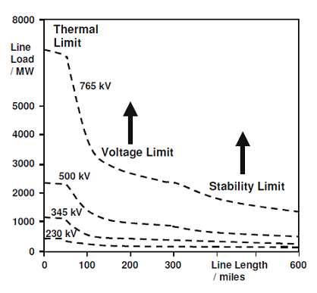 **Fig.1.1.Operational limits of transmission line for different voltage levels**

What is most interesting for transmission planners is that FACTS technology opens up new opportunities for controlling power and enhancing the usable capacity of present, as well as new and upgraded, lines. The possibility that current through a line can be controlled at a reasonable cost enables a large potential of increasing the capacity of existing lines with larger conductors, and use of one of the FACTS Controllers to enable corresponding power to flow through such lines under normal and contingency conditions. These opportunities arise through the ability of FACTS Controllers to control the interrelated parameters that govern the operation of transmission systems including series impedance, shunt impedance, current, voltage, phase angle, and the damping

of oscillations at various frequencies below the rated frequency. These constraints cannot be overcome, while maintaining the required system reliability, by mechanical means without lowering the useable transmission capacity. By providing added flexibility, FACTS Controllers can enable a line to carry power closer to its thermal rating. Mechanical switching needs to be supplemented by rapid-response power electronics. It must be emphasized that FACTS is an enabling technology, and not a one-on-one substitute for mechanical switches.

1.5. Types of FACTS Controllers

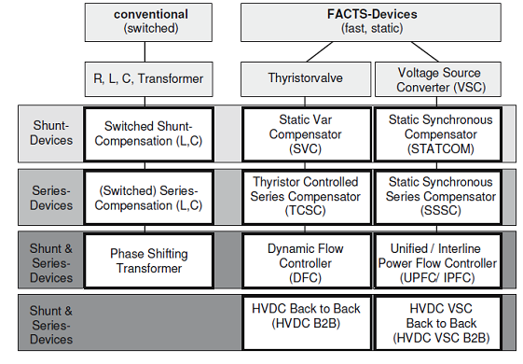

**Fig.1.2.Overview of major FACTS devices**

The left column in Figure 1.2 contains the conventional devices build out of fixed or mechanically switch able components like resistance, inductance or capacitance together with transformers. The FACTS-devices contain these elements as well but use additional power electronic valves or converters to switch the elements in smaller steps or with switching patterns within a cycle of the alternating current. The left column of FACTS-devices uses Thyristor valves or converters. These valves or converters are well known since several years. They have low losses because of their low switching frequency of once a cycle in the converters or the usage of the Thyristors to simply bridge impedances in the valves.

The right column of FACTS-devices contains more advanced technology of voltage source converters based today mainly on Insulated Gate Bipolar Transistors (IGBT) or Insulated Gate Commutated Thyristors (IGCT). Voltage Source Converters provide a free controllable voltage in magnitude and phase due to a pulse width modulation of the IGBTs or IGCTs. High modulation frequencies allow to get low harmonics in the output signal and even to compensate disturbances coming from the network. The disadvantage is that with an increasing switching frequency, the losses are increasing as well. Therefore special designs of the converters are required to compensate this.(thyristor controlled reactor) through a step-down transformer. The rating of the reactor is chosen larger than the rating of the capacitor by an amount to provide the maximum lagging vars that have to be absorbed from the system. By changing the firing angle of the thyristor controlling the reactor from 90° to 180°, the reactive power can be varied over the entire range from maximum lagging vars to leading vars that can be absorbed from the system by this compensator.

In general, FACTS Controllers can be divided into four categories:

1. Series controllers

2. Shunt controllers

3. Combined series-series controllers

4. Combined series-shunt controllers

**Series Controllers**

A series controller could be variable impedance such as capacitor reactor or power electronics based variable source of main frequency, sub synchronous and harmonic frequencies (or a combination) to serve the desired need. In principle, all series controllers inject voltage in series with the line. Even variable impedance multiplied by the current flow through it, represents an injected series voltage in the line. Different types available are as follows:

* Static Synchronous Series Compensator (SSSC)
* Interline Power Flow Controller (IPFC)
* Thyristor-Controlled Series Reactor (TCSR)
* Thyristor-Switched Series Reactor (TSSR)
* Thyristor-Controlled Series Capacitor (TCSC)
* Thyristor-Switched Series Capacitor (TSSC)

**Shunt Controllers**

In principle all shunt Controllers inject current into the system at point of connections. Even variable shunt impedance connected to the line voltage causes a variable current flow and hence represents injection of current into the line. Different types available listed below.

* Static Synchronous Compensator (STATCOM)
* Static Synchronous Generator (SSG)
* Static Var Compensator (SVC)
* Thyristor Controlled Reactor (TCR)
* Thyristor Switched Reactor (TSR)
* Thyristor Switched Capacitor (TSC)

**Combined Series-Series Controllers**

This could be a combination of separate series controllers, which are controlled in a coordinated manner in a multiline transmission system. The real power transfer ability of the unified series-series controller, referred to as interline power flow controller, makes it possible to balance both the real and reactive power flow in the lines thereby maximize the utilization of the transmission system.

* Interline Power Flow Controller (IPFC)

**Combined Shunt-Series Controller**

This could be a combination of separate series and shunt controllers, which are controlled in a coordinated manner or UPFC with the series and shunt elements. In principle, combined shunt and series controllers inject current into the system with the shunt part of the controller and voltage in series in the line with the series part of the controller. When series and shunt controllers are unified, there can be a real power exchange between the series and shunt controllers via the power link. Different types are listed below.

* Unified Power Flow Controller (UPFC)
* Thyristor-Controlled Phase Shifting Transformers (TCPST)

**1.6. Symbols for FACTS Controllers**

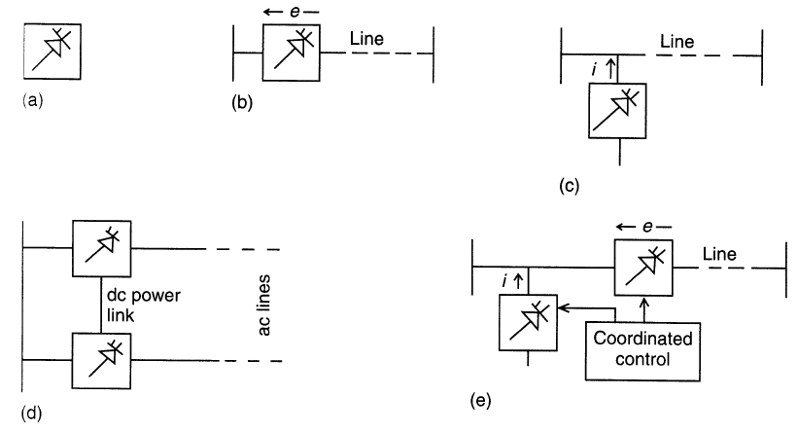

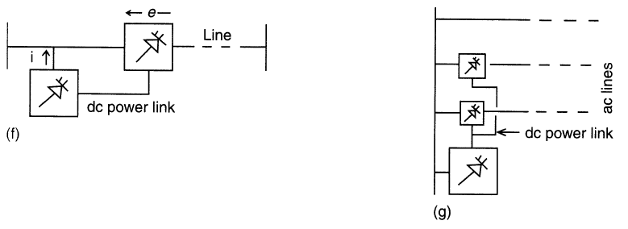

**Fig.1.3.General symbols of FACTS controllers**

1. **General symbol for a FACTS Controllers**
2. **Series controller**
3. **Shunt controller**
4. **Combined series-series controller**
5. **Combined shunt-series controller**
6. **Unified series-shunt controller**
7. **Unified controller for multiple lines**

2. **LITERATURE SURVEY**

**Renjie Ding, Jun Zhang, Yong Min, Zhiqiang Shi, Haitao Song And Yuwei Zhao** presented the design and implementation of a new kind of FCTCR controller based on multiprocessor and digital phase shift triggerswhich are helpful for controlling the harmonics in a transmission system by reducing the reactive power in order to improve the power quality and provides dampen power swing, reduce system losses and control active and reactive power flow.

Hence it is concluded that SVC (Static VAR Compensator) will successfully control the dynamic performance of power system and voltage regulation of the power system. The variation of reactive power with the variation in the firing angle is studied. The range of reactive power control can be increased by using the combination of thyristor controlled reactor and fixed capacitor system. The circuit model for FC-TCR is obtained and the same is used for simulation using MATLAB Simulink. From the simulation studies it is observed that the reactive power variation is smoother by using FC TCR system. Reactive power drawn by the load increases with FC-TCR since the bus voltage increases. The simulation results are almost similar to the theoretical results.

**Priyanath Das, SunitaHalder nee Dey, AbhijitChakrabarti and TanayaDutta** presented A Comparative Study in Improvement of Voltage Security in A Multi-Bus Power System using STATCOM and SVC. Which improves the dynamic, transient stability and security also compensate the reactive power in order to improve the power quality. The SVC will reciprocate with same features but limited transient stability, which also depend SVC operational components. The instrumental approach to regulate the voltage and system stability were exceptional by using STATCOM and SVC controllers, which are showing how voltage control would improve the power system quality..

**Sidhartha Panda,** presentedModeling, Simulation and optimal tuning of SSSC-based controller in a multi-machine power system, FACTS controllers are viable alternatives to problems in power systems. Among SSSC and DVR, even though both are series connected devices ,they differ in their location, overall complexity ,rating and control strategies. An SSSC is placed mainly in transmission system and has the capability to mitigate problems such as SSR. It increases the transmission capability of line. An SSSC normally has a higher power rating compared to DVR. An energy storage device may also be incorporated with SSSC .The control circuit of SSSC is more complicated than DVR. A DVR is mainly incorporated in the distribution side.It is less costly compared to SSSC. It can be used to mitigate many power quality problems in the load side. Control strategies are also relatively simple.

**S. Muthukrishnan, Dr. A Nirmal Kumar and G. Murugananth**, presented paper on Modeling and Simulation Five Level Inverter based UPFC System, In this study, a brief review of UPFC (FACTS), the essential features of UPFC controller and mathematical & simulation model was discussed .the potential to enhancement of power system stability was explained. In power system transmission, it is required to maintain the voltage magnitude, phase angle and line impedance. Consequently, to control power flow over designated transmission line and enhancement of power system stability FACTS devices are used in modern power system network. In this paper the role of UPFC device in power system and current status of electric power system network are addressed. Therefore, following results are found power flow control is achieved by using FACTS (UPFC) devices. Transient stability is improved and faster steady state is achieved. Hence congestion is less by improving transient stability.

**AhadKazemi and BabakBadrezadeh**, presented Modeling and Simulation of SVC and TCSC to Study their Effects on Maximum Load ability point precisely explained about the operation, characteristic curve and resonance condition of TCSC. This paper The main purpose of this paper is to lay a strong foundation on TCSC. From that point, this paper inspects the single and multi resonance condition for different value of inductance by MATLAB simulation. In accordance with resonance behavior, used to select an appropriate value of inductance and capacitance. Simulink modeled TCSC device was presented and relevant waveforms are analyzed in detail.

**3. POWER QUALITY**

**3.1 Introduction**

Power quality, or more specifically, a power quality disturbance, is generally defined as any change in power (voltage, current, or frequency) that interferes with the normal operation of electrical equipment. The study of power quality, and ways to control it, is a concern for electric utilities, large industrial companies, businesses, and even home users. The study has intensified as equipment has become increasingly sensitive to even minute changes in the power supply voltage, current, and frequency. Unfortunately, different terminology has been used to describe many of the existing power disturbances, which creates confusion and makes it more difficult to effectively discuss, study, and make changes to today’s power quality problems. The Institute of Electrical and Electronics Engineers (IEEE) has attempted to address this problem by developing a standard that includes definitions of power disturbances. The standard (IEEE Standard 1159 1995, "IEEE Recommended Practice for Monitoring Electrical Power Quality") describes many power quality problems, of which this paper will discuss the most common. Commercial ac power appears as a smooth, symmetrical sine wave, varying at either 50 cycles every second (Hertz – Hz). The sinusoidal wave shape, voltage changes from a positive value to a negative value, 50 times per second. When this flowing wave shape changes size, shape, symmetry, frequency, or develops notches, impulses, ringing, or drops to zero (however briefly), there is a power disturbance. As stated, there has been some ambiguity throughout the electrical industry and businesses community in the use of terminology to describe various power disturbances. For example, the term “surge” is seen by one sector of the industry to mean a momentary increase in voltage as would be typically caused by a large load being switched off. On the other hand, usage of the term “surge” can also be seen as a transient voltage lasting from microseconds to only a few milliseconds with very high peak values. These latter are usually associated with lightning strikes and switching events creating sparks or arcing between contacts. A communication mistake can have expensive consequences, which includes downtime, or even equipment damage.

**3.2 Classification Of Power Quality**

This IEEE defined power quality disturbances shown in this paper have been organized into seven categories based on wave shape:

1. Transients.
2. Interruptions.
3. Sag / under voltage.
4. Swell / Overvoltage.
5. Waveform distortion.
6. Voltage fluctuations.
7. Frequency variations.
8. **Transients**

Potentially the most damaging type of power disturbance, transients fall into two subcategories:

1. Impulsive

2. Oscillatory

Impulsive transients are sudden high peak events that raise the voltage and/or current levels in either a positive or a negative direction. Causes of impulsive transients include lightning, poor grounding, the switching of inductive loads, utility fault clearing, and ESD (Electrostatic Discharge). The results can range from the loss (or corruption) of data, to physical damage of equipment. Of these causes, lightning is probably the most damaging.

An oscillatory transient is a sudden change in the steady-state condition of a signal's voltage, current, or both, at both the positive and negative signal limits, oscillating at the natural system frequency. In simple terms, the transient causes the power signal to alternately swell and then shrink, very rapidly. Oscillatory transients usually decay to zero within a cycle (a decaying oscillation). These transients occur when you turn off an inductive or capacitive load, such as a motor or capacitor bank. An oscillatory transient results because the load resists the change.

1. **Interruption**

An interruption is defined as the complete loss of supply voltage or load current. Depending on its duration, an interruption is categorized as instantaneous, momentary, temporary, or sustained.

Types

1. Instantaneous 0.5 to 30 cycles.
2. Momentary 30 cycles to 2 seconds.
3. Temporary 2 seconds to 2 minutes.
4. Sustained greater than 2 minutes.

Solutions to help against interruptions vary, both in effectiveness and cost. The first effort should go into eliminating or reducing the likelihood of potential problems. Good design and maintenance of utility systems are, of course, essential. This also applies to the industrial customer's system design, which is often as extensive and vulnerable as the utility system.

**3.Sag**

Sag is a reduction of AC voltage at a given frequency for the duration of0.5cycles to 1 minute’s time. Sags are usually caused by system faults, and are also often the result of switching on loads with heavy start-up currents. Some of the same techniques that were used to address interruptions can be utilized to address voltage sags: UPS equipment, motor generators, and system design techniques. However, sometimes the damage being caused by sags is not apparent until the results are seen over time.

Under voltages are the results of long-term problems that create sags. The term “brownout” has been commonly used to describe this problem, and has been super ceded by the term under voltage. Under-voltages can create overheating in motors, and can lead to the failure of nonlinear loads such as computer power supplies. The solution for sags also applies to under-voltages. More importantly, if an under voltage remains constant, it may be a sign of a serious equipment fault, configuration problem, or that the utility supply needs to be addressed.

4. **Swell / Overvoltage.**

A swell is the reverse form of sag, having an increase in AC voltage for duration of 0.5 cycles to 1 minute’s time. For swells, high-impedance neutral connections, sudden (especially large) load reductions, and a single-phase fault on a three-phase system are common sources. The result can be data errors, flickering of lights, degradation of electrical contacts, semiconductor damage in electronics, and insulation degradation. Power line conditioners, UPS systems, and Ferro resonant "control" transformers are common solutions.

**Over voltages**

Over voltages (Figure 10) can be the result of long-term problems that create swells. An overvoltage can be thought of as an extended swell. Overvoltages are also common in areas where supply transformer tap settings are set incorrectly and loads have been reduced.

5. **Waveform Distortion**

There are five primary types of waveform distortion:

a).DC offset

b).Harmonics

c). Inter harmonics

d).Notching

e).Noise

1. **DC offset**

Direct current (dc) can be induced into an ac distribution system, often due to failure of rectifiers within the many ac to dc conversion technologies that have proliferated modern equipment. DC can traverse the ac power system and add unwanted current to devices already operating at their rated level. When a transformer saturates, it not only gets hot, but also is unable to deliver full power to the load, and the subsequent waveform distortion can create further instability.

1. **Harmonics**

Harmonic distortion is the corruption of the fundamental sine wave at frequencies that are multiples of the fundamental. Symptoms of harmonic problems include overheated transformers, neutral conductors, and other electrical distribution equipment, as well as the tripping of circuit breakers and loss of synchronization on timing circuits that are dependent upon a clean sine wave trigger at the zero crossover point.

Harmonic distortion has been a significant problem with IT equipment in the past, due to the nature of switch-mode power supplies (SMPS). These non-linear loads, and many other capacitive designs, instead of drawing current over each full half cycle, “sip” power at each positive and negative peak of the voltage wave. The return current, because it is only short-term, (approximately 1/3 of a cycle) combines on the neutral with all other returns from SMPS using each of the three phases in the typical distribution system. Instead of subtracting, the pulsed neutral currents add together, creating very high neutral currents, at a theoretical maximum of 1.73 times the maximum phase current. An overloaded neutral can lead to extremely high voltages on the legs of the distribution power, leading to heavy damage to attached equipment. At the same time, the load for these multiple SMPS is drawn at the very peaks of each voltage half-cycle, which has often led to transformer saturation and consequent overheating. Other loads contributing to this problem are variable speed motor drives, lighting ballasts and large legacy UPS systems. Methods used to mitigate this problem have included over-sizing the neutral conductors, installing K-rated transformers, and harmonic filters.

Spurred on by the remarkable expansion of the IT industry over the last decade, power supply design for IT equipment has been upgraded via international standards. One major change compensates for electrical infrastructure stresses caused, in the recent past, by large clusters of IT equipment power supplies contributing to excessive harmonic currents within a facility. Many new IT equipment power supplies have been designed with power-factor corrected power supplies operating as linear, non-harmonic loads. These power supplies do not produce the waste current of harmonics.

**Harmonics Mitigation Techniques**

The generation of harmonics, whenever an adjustable speed drive is used, is inevitable. The order and magnitude of these harmonics will greatly depend on the drive configuration and system impedance. The various harmonic mitigation techniques available are as follows:

**Phase Multiplication**:

whether the drive is AC or DC, the common means of reducing harmonics generation while in the design process is by phase multiplication or harmonic cancellation. It is effective in reducing low order harmonics as long as the load is balanced.

**Passive filters**:

Improved power factor reduces high frequency harmonics. Large tuning reactors are not used as instability may occur due to parallel resonance with the source impedance. Performance depends upon source impedance; it cannot be measured accurately and can vary with system changes. Hence, passive filters are not appropriate for cycloconverters.

**Active filters**:

With improved power factor, the output current can be controlled. Active filters provide stable operation against AC source impedance variation, and fast responsive irrespective of the order and magnitude of harmonics. These filters are appropriate for cycloconverters. The initial and running costs are usually higher than passive filters. The injection may flow into other components.

**Harmonic injection**:

Harmonic injection takes care of uncharacteristic harmonics. System impedance is not a part of the design criteria as it may give rise to low order harmonics

**3.3 Harmonic mitigation techniques with PWM**:

Harmonics can be reduced to less than one per cent of the fundamental with the help of PWM; it is programmable to eliminate specific harmonics. In addition to the above techniques, harmonics can be reduced by a number of circuit techniques.

**c. Interharmonics**

Interharmonics are a type of waveform distortion that are usually the result of a signal imposed on the supply voltage by electrical equipment such as static frequency converters, induction motors and arcing devices. Cycloconverters (which control large linear motors used in rolling mill, cement, and mining equipment), create some of the most significant interharmonic supply power problems. These devices transform the supply voltage into an AC voltage of a frequency lower or higher than that of the supply frequency.

The most noticeable effect of interharmonics is visual flickering of displays and incandescent lights, as well as causing possible heat and communication interference. Solutions to interharmonics include filters, UPS systems, and line conditioners.

d. **Notching**

Notching is a periodic voltage disturbance caused by electronic devices, such as variable speed drives, light dimmers and arc welders under normal operation. This problem could be described as a transient impulse problem, but because the notches are periodic over each ½ cycle, notching is considered a waveform distortion problem. The usual consequences of notching are system halts, data loss, and data transmission problems.

One solution to notching is to move the load away from the equipment causing the problem (if possible). UPSs and filter equipment are also viable solutions to notching if equipment cannot be relocated.

e. **Noise**

Noise is unwanted voltage or current superimposed on the power system voltage or current waveform. Noise can be generated by power electronic devices, control circuits, arc welders, switching power supplies, radio transmitters and so on. Poorly grounded sites make the system more susceptible to noise. Noise can cause technical equipment problems such as data errors, equipment malfunction, long term component failure, hard disk failure, and distorted video displays.

There are many different approaches to controlling noise and sometimes it is necessary to use several different techniques together to achieve the required result. Some methods are:

* Isolate the load via a UPS.
* Install a grounded, shielded isolation transformer.
* Relocate the load away from the interference source.
* Install noise filters.
* Cable shielding.

6. **Voltage Fluctuations**

Since voltage fluctuations are fundamentally different from the rest of the waveform anomalies, they are placed in their own category. A Voltage fluctuation is a systematic variation of the voltage waveform or a series of random voltage changes, of small dimensions, namely 95 to 105% of nominal at a low frequency, generally below 25 Hz.

Any load exhibiting significant current variations can cause voltage fluctuations. Arc furnaces are the most common cause of voltage fluctuation on the transmission and distribution system. One symptom of this problem is flickering of incandescent lamps. Removing the offending load, relocating the sensitive equipment, or installing power line conditioning or UPS devices, are methods to resolve this problem.

7. **Frequency Variations**

Frequency variation (Figure 18) is extremely rare in stable utility power systems, especially systems interconnected via a power grid. Where sites have dedicated standby generators or poor power infrastructure, frequency variation is more common especially if the generator is heavily loaded. IT equipment is frequency tolerant, and generally not affected by minor shifts in local generator frequency. What would be affected would be any motor device or sensitive device that relies on steady regular cycling of power over time. Frequency variations may cause a motor to run faster or slower to match the frequency of the input power. This would cause the motor to run inefficiently and/or lead to added heat and degradation of the motor through increased motor speed and/or additional current draw.

To correct this problem, all generated power sources and other power sources causing the frequency variation should be assessed, then repaired, corrected, or replaced.

**8.Voltage Imbalance**

A voltage imbalance is not a type of waveform distortion. a voltage imbalance (as the name implies) is when supplied voltages are not equal. While these problems can be caused by external utility supply, the common source of voltage imbalances is internal, and caused by facility loads. More specifically, this is known to occur in three phase power distribution system where one of the legs is supplying power to single phase equipment, while the system is also supplying power to three phase loads.

A quick way to assess the state of voltage imbalance is to take the difference between the highest and the lowest voltages of the three supply voltages. This number should not exceed 4% of the lowest supply voltage. Below is an example of this quick way to get a simple assessment of the voltage imbalance in a system.

**3.4 Solutions to Power Quality Problems**

There are two approaches to the mitigation of power quality problems. The solution to the power quality can be done from customer side or from utility side. First approach is called load conditioning, which ensures that the equipment is less sensitive to power disturbances, allowing the operation even under significant voltage distortion. The other solution is to install line conditioning systems that suppress or counteracts the power system disturbances. A flexible and versatile solution to voltage quality problems is offered by active power filters. Currently they are based on PWM converters and connect to low and medium voltage distribution system in shunt or in series. Series active power filters must operate in conjunction with shunt passive filters in ord er to compensate load current harmonics. Shunt active power filters operate as a controllable current source and series active power filters operates as a controllable voltage source. Both schemes are implemented preferable with voltage source PWM inverters, with a dc bus having a reactive element such as a capacitor. Active power filters can perform one or more of the functions required to compensate power systems and improving power quality. Their performance also depends on the power rating and the speed of response.

Solutions will play a major role in improving the inherent supply quality; some of the effective and economic measures can be identified as following:

1. **Lightening and Surge Arresters:**

Arresters are designed for lightening protection of transformers, but are not sufficiently voltage limiting for protecting sensitive electronic con trol circuits from voltage surges.

1. **Thyristor Based Static Switches:**

The static switch is a versatile device for switching a new element into the circuit when the voltage support is needed. It has a dynamic response time of about one cycle. To correct quickly for voltage spikes, sags or interruptions, the static switch can used to switch one or more of devices such as capacitor, filter, alternate power line, energy storage systems etc. The static switch can be used in the alternate power line applications. This scheme requires two independent power lines from the utility or could be from utility and localized power generation like those in case of distributed generating systems [4]. Such a scheme can protect up to about 85 % of interruptions and voltage sags.

**C. Energy Storage Systems:**

Storage systems can be used to protect sensitive production equipments from shutdowns caused by voltage sags or momentary interruptions. These are usually DC storage systems such as UPS, batteries, superconducting magnet energy storage (SMES), storage capacitors or even fly wheels driving DC generators [6]. The output of these devices can be supplied to the system through an inverter on a momentary basis by a fast acting electronic switch. Enough energy is fed to the system to compensate for the energy that would be lost by the voltage sag or interruption. In case of utility supply backed by a localized generation this can be even better accomplished.

**D. Electronic tap changing transformer:**

A voltage-regulating transformer with an electronic load tap changer can be used with a single line from the utility. It can regulate the voltage drops up to 50% and requires a stiff system (short circuit power to load ratio of 10:1 or better). It can have the provision of coarse or smooth steps intended for occasional voltage variations.

**E. Harmonic Filters**

Filters are used in some instances to effectively reduce or eliminate certain harmonics. If possible, it is always preferable to use a 12-pluse or higher transformer connection, rather than a fil ter. Tuned harmonic filters should be used with caution and avoided when possible. Usually, multiple filters are needed, each tuned to a separate harmonic. Each filter causes a parallel resonance as well as a series resonance, and each filter slightly changes the resonances of other filters.

**F. Constant-Voltage Transformers:**

For many power quality studies, it is possible to greatly improve the sag and momentary interruption tolerance of a facility by protecting control circuits. Constant voltage transformer (CVTs) can be used on control circuits to provide constant voltage with three cycle ride through, or relays and ac contactors can be provided with electronic coil hold-in devices to prevent mis-operation from either low or interrupted voltage.

**G. Digital-Electronic and Intelligent Controllers for Load-Frequency Control:**

Frequency of the supply power is one of the major determinants of power quality, which affects the equipment performance very drastically. Even the major system components such as Turbine life and interconnected-grid control are directly affected by power frequency.

**4.** **BASIC DESCRIPTION OF FACTS DEVICES**

**4.1. Fixed capacitor thyristor controlled reactor (FC-TCR)**

Static VAR compensated FACTS device are the most important device and have been used for a number of years to improve voltage and power flow through the transmission line by resolving dynamic voltage problems. SVC is shunt connected static generator/absorber. Utilities of SVC controller in transmission line are many

a) provides high performance in steady-state and transient voltage stability control,

b) Dampen power swing,

c) Reduce system loss,

d) Control real and reactive power flow.

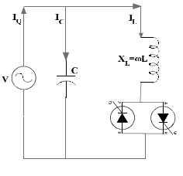

**Fig.4.1.Fixed capacitor thyristor controlled reactor (FC-TCR)**

The control objective of SVC is to maintain the desired voltage at a high voltage bus . In steady state, the SVC will provide some steady- state control of the voltage to maintain it the highest voltage bus at the pre-defined level. If the voltage bus begins fall below its set point range, the SVC will inject reactive power (Q net) into the system (within its control limits), thereby increasing the bus voltage back to its desired voltage level. If bus voltage increases, the SVC will inject less (or TCR will absorb more) reactive power (within its control limits), and the result will be to achieve the desired bus voltage. The Fixed Capacitor Thyristor-Controlled Reactor (FC-TCR) is a var generator arrangement using a fixed (permanently connected) capacitance with a thyristor controlled reactor as shown in figure.

Simple FC-TCR type SVC configuration is shown in figure 1. In FC-TCR,a capacitor is placed in parallel with a thyristor controlled reactor. Is, Ir and Ic are system current, reactor current and capacitor current respectively which flows through the FC-TCR circuit. Fixed capacitor- Thyristor controlled reactor (FC-TCR) can provide continuous lagging and leading VARS to the system [5]. Circulating current through the reactor (Ir) is controlled by controlling the firing angle of back-back thyristor valves connected in series with the reactor. Leading var to the system is supplied by the capacitor. For supplying lagging vars to the system, TCR is generally rated larger than the capacitor.

**4.2 Static synchronous compensator (STATCOM)**

A static synchronous generator operated as a shunt –connected static var compensator whose capacitive or inductive output current can be controlled independent of the ac system voltage. For the voltage-sourced converter, its ac output voltage is controlled such that it is just right for the required reactive current flow for any ac bus voltage dc capacitor voltage is automatically adjusted as require serving as a voltage source for the converter. STATCOM also designed to act as an active filter to absorb system harmonics. Figures show the schematic diagram of STATCOM without energy storage system and with energy storage system the static synchronous compensator (STATCOM) is another shunt connected GTO based FACTS device. STATCOM is a static synchronous generator operated as a static VAR compensator which can inject lagging or leading var into the system. STATCOM have several advantages. It has no rotating parts, very fast in response, requires less space as bulky passive components are eliminated, inherently modular and reloadable, less maintenance and no problem as loss of synchronism.

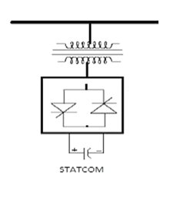

**Fig.4.2.Static Synchronous Compensator (STATCOM)**

Simple diagram of STATCOM is shown in figure. The dc source voltage is converted into ac voltage by the voltage source converter using GTO and ac voltage is inserted into the line through the transformer. In heavy loaded condition if. Output of VSC is more than the line voltage, converter supplies lagging VARs to the transmission line. During low load condition if line voltage is more than then converter absorbs lagging VAR from the system. If o/p voltage of converter is equal to line voltage, then the STATCOM is in floating condition and this shunt device does not supply or absorb reactive power to the system or from the system.

**4.3. Thyristor controlled series capacitor (TCSC)**

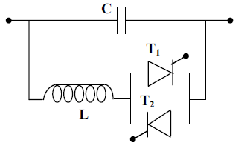

**Fig.4.3.Thyristor controlled series capacitor (TCSC)**

Thyristor-controlled series capacitors (TCSC) is also a type of series compensator, can provide many benefits for a power system including controlling power flow in the line, damping power oscillations, and mitigating sub synchronous resonance. The TCSC concept is that it uses an extremely simple main circuit. The capacitor is inserted directly in series with the transmission line and the thyristor-controlled inductor is mounted directly in parallel with the capacitor. Thus no interfacing equipment like e.g. high voltage transformers is required. This makes TCSC much more economic than some other competing FACTS technologies. Thus it makes TCSC simple and easy to understand the operation.

World’s first 3 phase, 2 X 165 MVAR, TCSC was installed in 1992 in Kayenta substation, Arizona. It raised the transmission capacity of transmission line by 30%, but it was soon realized that the device is also a very effective means for providing damping of electromechanical power oscillations. A third possible application of TCSC emerged from the on site observations that it can provide series compensation without causing the same risk for sub-synchronous resonance (SSR) as a fixed series capacitor. World’s first TCSC for sub synchronous resonance (SSR) mitigation was installed in Strode, Sweden in 1998, by ABB. Specifically this period makes a valiant period for TCSC and makes the researchers to turn on to TCSC The main purpose of this paper is to furnish a concise study of TCSC in simple way.

Thyristor controlled series capacitor (TCSC) is very important series compensator like SSSC. Especially in this FACTS (Flexible alternating transmission system) device, thyristor with gate turn-off capability is not required. Figure 3 shows schematic diagram of a TCSC controller. In TCSC, capacitor is inserted directly into the transmission line and TCR are mounted in parallel with the capacitor. As the capacitor is inserted in series with the line, there is no need of using high voltage transformer and thus it gives better economy. Firing angle of back to back thyristors are controlled to control the reactor. At 180° firing angle TCR, is non-conducting and at 90° firing angle TCR is in full conduction.

**4.4. Static synchronous series compensator (SSSC)**

The inverter based series compensator, which is now often termed the SSSC, was first proposed in 1989 by Gyugyi .SSSC has several advantages over TCSC (Thyristor controlled series capacitor).

(i) These include elimination of bulky passive components, capacitors and reactors

(ii) Improved technical characteristics

(iii) Symmetric capability in both capacitive and inductive operating modes

(iv) Possibility of connecting an energy source on the DC side to exchange real power with the AC network.

Figure shows basic diagram of SSSC connected to a transmission line. It consists of a series injection transformer which injects the required voltage in series with the line. The voltage source converter is a PWM converter whose output voltage is determined by switching of PWM converters. The DC link capacitor of SSSC maintains a constant DC bus voltage for the converter. The control circuit controls the switching of the converter ,by operating it at the required time.

A Static synchronous series generator operated without an external electric energy source as a series compensator whose output voltage is in quadrature with and controlled independently of the line current for the purpose of increasing or decreasing overall reactive voltage drop across the line and thereby controlling the transmitted electric power. The SSSC may include transiently rated energy storage or energy absorbing devices to enhance the dynamic behavior of the power system by additional temporary real power compensation to increase or decrease momentarily the overall real voltage drop across the line.

In present days, SSSC is one of the most important FACTS controller used for series compensation of power. In series compensation the capacitor which is connected in series compensates the inductive reactance of the transmission line. SSSC output voltage (Vc) is in quadrature with the line current (I).

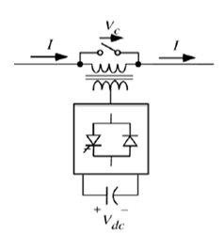

**Fig.4.4.Static Synchronous Series Compensator (SSSC)**

The voltage across series capacitor is –jXcI (where Xc is the capacitive reactance of the series capacitor) and voltage drop across line inductance (XL) is +jXLI cancel each other thus reducing the effect of line inductance. Due to this, power transfer capability is increased [5].The symbolic representation of SSSC using voltage source converter is shown in figure 4. Supply voltage from a dc source is converted into ac voltage using VSC (voltage source converter). Quadrature voltage is injected into the line through a coupling transformer. This injected voltage (Vc) lags the line current (I) by 90ºand series compensation is done. SSSC control flow of real and reactive power through the system.

**4.5. Unified power flow controller (UPFC)**

UPFC concept was proposed by GyuGyi in 1991. The UPFC was devised for real time control and dynamic compensation of ac transmission systems. It provides multifunctional flexibility to solve many of the issues facing the power delivery industries. UPFC is able to control synchronic or individually all the parameters (i.e. voltage, phase angle, and impedance) affecting power flow in the power system network. Thus this unique capability is announced by the adjective “unified” the main reason behind the wide spreads of UPFC are its ability to power flow bi-directionally maintaining well regulated DC voltage, workability in the wide range of operating conditions.

This is the second or latest generation of FACTS technology. This FACTs device combines the two features of two other FACTS devices STATCOM (static synchronous compensator) and SSSC (the static synchronous series compensator). Basically these devices are voltage source converters (VSC’s) .the UPFC is a generally synchronous voltage source (SVS). The SVS usually exchange both reactive and real power with the transmission system. Frankly speaking an SVS is able to generate only reactive power exchanged; the real power must be supplied to it, or absorbed from it by a suitable power supply or link.



**Fig.4.5.Unified power flow controller (UPFC)**

Figure shows a schematic diagram of UPFC. Full form of UPFC is Unified power flow controller. The word unified signifies all parameters (e.g.- voltage, phase angle, impedance, real and reactive power and power factor) which effect power flow in the system can be controlled . UPFC is the most modernized device among all the FACTS devices which can be used to enhance steady-state stability, dynamic stability, real and reactive power flow and so on. UPFC consists of two converters. One converter (SSSC) is connected in series with the transmission line and other converter (STATCOM) is connected in parallel with the transmission line. The two converters are coupled through a common dc link which provides bidirectional flow of real power between series o/p SSSC and shunt output STATCOM respectively.

**5. PROPOSED CONCEPTS**

**5.1. Introduction**

Research works are going on in finding newer concept for minimizing the reason of voltage collapse by increasing voltage stability (Dynamic, Transient and Steady-state stability), voltage margin and voltage security in the system. Voltage collapse is a major problem of power system and it occurs due to voltage instability. There are many analysis methods for determining voltage stability based on power flow. Steady- state stability is the ability of power system to control after small disturbances e.g.:- change in load. In dynamic performance of two area power system with and without UPFC have been studied and compared with other FACTS (Flexible alternating current transmission system) devices. Various types of FACTS controllers and their performance characteristics have been described in. It is essential to analyze voltage stability for a secure power system. Static VAR compensator (SVC) and Thyristor controlled series capacitor (TCSC) increased system stability by placing SVC Flexible AC transmission system controller at different places steady- state stability of system can improve.

FACTS (Flexible alternating current transmission system) are mainly used for solving instability problems. Recently it has been noted that FACTS controllers can also be used for power flow control and stability enhancement control. Use of FACTS controllers for improving transient stability of a system has been investigated in. Comparison of the Power electronic controllers were first introduced in HVDC transmission for improving power flow and system stability. There are four types of controllers in FACTS device family. Series controllers are used to inject voltage in series with the line and directly control voltage and current, performances of shunt capacitor, FC-TCR type SVC and STATCOM using MATLAB/SIMULINK software has been done in. In the effect of SVC and STATCOM for static voltage stability margin enhancement is studied. Simulation and comparison of various FACTS devices (FC-TCR, UPFC) using Program with integrated circuits Emphasis (PSPICE) software has been done in showing power transfer control. In, how FACTS devices are used for power quality improvement and finally improve impedance, current and voltage in improving power system operation have been studied. In, modeling and simulation of SSSC multi-machine system for power system stability enhancement is studied. In saddle node bifurcation analysis is applied for finding optimal location of SVC and TCSC, power flow is used to evaluate the effect of FACTS device on system load ability.

In this paper modeling and simulation of various FACTS (Flexible alternating current transmission system) devices have been done using MATLAB/SIMULINK software. These FACTS devices (FC-TCR, STATCOM, TCSC, SSSC, and UPFC) are controlled by controlling their source and line impedance value. First we determined the impedance value for better system performance. By varying the value of capacitor of all the above FACTS device models real and reactive power flow through the system is tabulated to find the FACTS device which gives better performance for a particular capacitor value.

In the evolving utility environment, financial and market forces are, and will continue to, demand a more optimal and profitable operation of the power system with respect to generation, transmission, and distribution. Now, more than ever, advanced technologies are paramount for the reliable and secure operation of power systems. To achieve both operational reliability and financial profitability, it has become clear that more efficient utilization and control of the *existing* transmission system infrastructure is required. Improved utilization of the existing power system is provided through the application of advanced control technologies. Power electronics based equipment, or Flexible AC Transmission Systems (FACTS), provide proven technical solutions to address these new operating challenges being presented today. FACTS technologies allow for improved transmission system operation with minimal infrastructure investment, environmental impact, and implementation time compared to the construction of new transmission lines. Traditional solutions to upgrading the electrical transmission system infrastructure have been primarily in the form of new transmission lines, substations, and associated equipment. However, as experiences have proven over the past decade or more, the process to permit, site, and construct new transmission lines has become extremely difficult, expensive, time-consuming, and *controversial*. FACTS technologies provide advanced solutions as cost-effective alternatives to new transmission line construction.

**5.2. Static VAR Compensator (SVC)**

Static VAR systems are applied by utilities in transmission applications for several purposes. The primary purpose is usually for rapid control of voltage at weak points in a network. Installations may be at the midpoint of transmission interconnections or at the line ends. Static Var Compensators are shunt connected static generators / absorbers whose outputs are varied so as to control voltage of the electric power systems. An SVC can improve power system transmission and distribution performance in a number of ways. Installing an SVC at one or more suitable points in the network can increase transfer capability and reduce losses while maintaining a smooth voltage profile under different network conditions. The dynamic stability of the grid can also be improved, and active power oscillations mitigated . To summarize the application of SVC gives the following benefits.

**In power transmission:**

- Stabilized voltages in weak systems

- Reduced transmission losses

- Increased transmission capacity, to reduce or remove the need for new lines

- Higher transient stability limit

- Increased damping of minor disturbances

- Greater voltage control and stability

- Power swing damping

**In power distribution:**

- Stabilized voltage at the receiving end of long lines

- Increased productivity as stabilized voltage better utilizes capacity

- Reduced reactive power consumption, gives lower losses and eliminates penalty tariffs

- Balanced asymmetrical loads reduce system losses

- Fewer stresses in asynchronous machinery

- Enables better use of equipment (particularly transformers and cables)

- Reduced voltage fluctuations and light Flicker

**6. MATLAB SIMULATION MODELLING**

MATLAB is a high-performance language for technical computing. It integrates computation, visualization, and programming in an easy-to-use environment where problems and solutions are expressed in familiar mathematical notation. Typical uses include-

* Math and computation
* Algorithm development
* Data acquisition
* Modeling, simulation, and prototyping
* Data analysis, exploration, and visualization
* Scientific and engineering graphics

MATLAB is an interactive system whose basic data element is an array that does not require dimensioning. This allows solving many technical computing problems, especially those with matrix and vector formulations, in a fraction of the time it would take to write a program in a scalar non-interactive language such as C or FORTRAN.

The MATLAB system consists of six main parts

**(a) Development Environment**

This is the set of tools and facilities that help to use MATLAB functions and files. Many of these tools are graphical user interfaces. It includes the MATLAB desktop and Command Window, a command history, an editor and debugger, and browsers for viewing help, the workspace, files, and the search path.

**(b) The MATLAB Mathematical Function Library**

This is a vast collection of computational algorithms ranging from elementary functions, like sum, sine, cosine, and complex arithmetic, to more sophisticated functions like matrix inverse, matrix Eigen values, Bessel functions, and fast Fourier transforms.

**(c)The MATLAB Language**

This is a high-level matrix/array language with control flow statements, functions, data structures, input/output, and object-oriented programming features. It allows both "programming in the small" to rapidly create quick and dirty throw-away programs, and "programming in the large" to create large and complex application programs.

**(d) Graphics**

MATLAB has extensive facilities for displaying vectors and matrices as graphs, as well as annotating and printing these graphs. It includes high-level functions for two-dimensional and three-dimensional data visualization, image processing, animation, and presentation graphics. It also includes low-level functions that allow to fully customize the appearance of graphics as well as to build complete graphical user interfaces on MATLAB applications.

**(e)The MATLAB Application Program Interface (API)**

This is a library that allows writing in C and FORTRAN programs that interact with MATLAB. It includes facilities for calling routines from MATLAB (dynamic linking), calling MATLAB as a computational engine, and for reading and writing MAT-files.

**(f) MATLAB Documentation**

MATLAB provides extensive documentation, in both printed and online format, to help to learn about and use all of its features. It covers all the primary MATLAB features at a high level, including many examples. The MATLAB online help provides task-oriented and reference information about MATLAB features. MATLAB documentation is also available in printed form and in PDF format.

**(g) Mat lab tools**

(i) **Three phase source block**

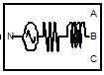



The Three-Phase Source block implements a balanced three-phase voltage source with internal R-L impedance. The three voltage sources are connected in Y with a neutral connection that can be internally ground.

(ii**) VI measurement block**

The Three-Phase V-I Measurement block is used to measure three-phase voltages and currents in a circuit. When connected in series with three-phase elements, it returns the three phase-to-ground or phase-to-phase voltages and the three line currents

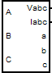



(iii) **Scope**

Display signals generated during a simulation. The Scope block displays its input with respect to simulation time. The Scope block can have multiple axes (one per port); all axes have a common time range with independent y-axes. The Scope allows you to adjust the amount of time and the range of input values displayed. You can move and resize the Scope window and you can modify the Scope's parameter values during the simulation





(iv). **Three-Phase Series RLC Load**

The Three-Phase Series RLC Load block implements a three-phase balanced load as a series combination of RLC elements. At the specified frequency, the load exhibits constant impedance. The active and reactive powers absorbed by the load are proportional to the square of the applied voltage.

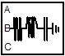

**Three-Phase Series RLC Load**

**(v) Three-Phase Breaker block**

The Three-Phase Breaker block implements a three-phase circuit breaker where the opening and closing times can be controlled either from an external Simulink signal or from an internal control signal.

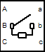

**Three-Phase Breaker block**

(vi) **Gain block**



**Gain block**

The Gain block multiplies the input by a constant value (gain). The input and the gain can each be a scalar, vector, or matrix.

**6.1. Performance Analysis of Facts Devices**

**6.1.1 Uncompensated System Model (Basic Transmission Line)**



**Fig.6.1.MATLAB/SIMULINK Model of Basic Transmission line**

Figure shows the basic transmission (11kV) model of an uncompensated system. This model consists of current measurement block, voltage measurement block, real and reactive power block and scopes. 11kv voltage is supplied from the AC voltage source to the system. Source impedance (0.01+0.001) Ω, Line impedance (5+0.023) Ω and load is kept constant at 25MW and 50MVAR for the above transmission line model. Simulation is done using MATLAB/SIMULINK. Current measurement block is used to measure the instantaneous source and load current flowing through the transmission line, Voltage measurement block is used to measure the source and load voltage. Real and reactive power in load side is measured using active and reactive power measurement block. Scopes display results after simulation. Above model provides three scopes: one displays the source voltage (V) and source current (I), second one displays real (P) and reactive (Q) power and third one displays load voltage (V1) and load current (I1) after simulation. Real and reactive power flows obtained after simulation are shown in below:

**Real power flow**

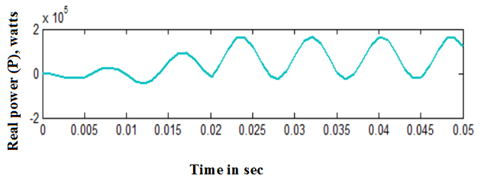

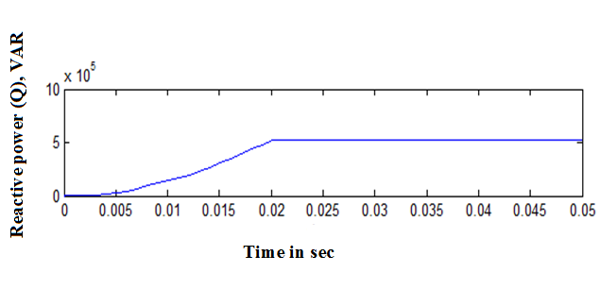

**Reactive Power flow**

**Fig.6.2.Simulation results for Basic transmission line**

Load voltage is found to be 2.1 kV. Real and reactive power flow is obtained without any compensation. So, in order to keep the system stable, we have to provide reactive power compensation. In this paper, to get better performance regarding voltage stability, five compensating devices have been studied and comparison has been done to find the device that gives best performance under a given operating condition. All the plots for the compensated systems have been shown for a particular capacitor value of 350μF.

**6.2. Compensated System FC-TCR**



**Fig.6.3.MATLAB/SIMULINK Model of FC-TCR Compensated system**

Line impedance is kept at (0.01+0.001) Ω and load is fixed at 25MW and 50MVAR. Results obtained after simulation of FC-TCR model is shown below

**Real power flow**

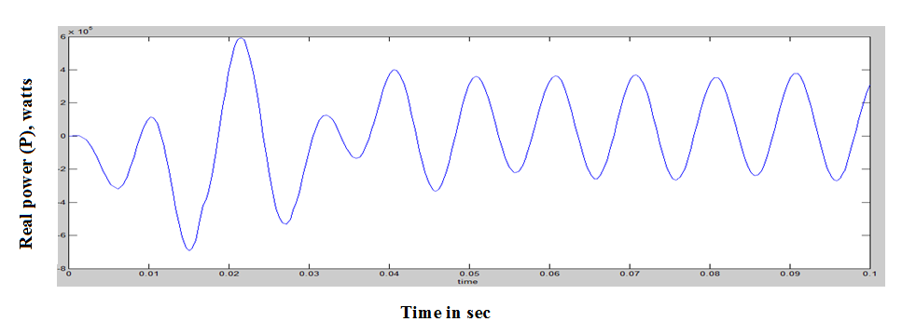

**Reactive power flow**

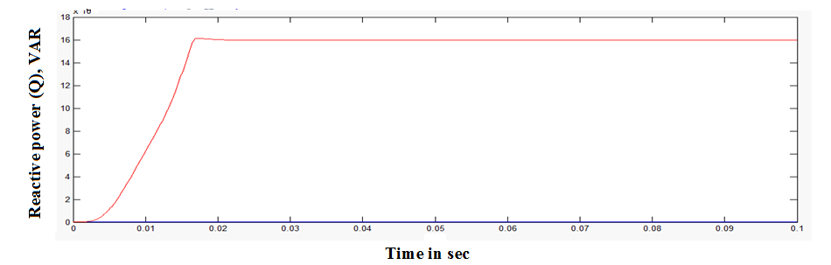

**Fig.6.4.Simulation result for FC-TCR**

Real and reactive powers have been obtained for a fixed value of TCR inductance (100mH) and for different values of the capacitor. Improvement obtained in real and reactive power with changes in capacitor values are tabulated below

TABLE: 6.1. Variation of power flow with change in capacitance of FC-TCR

|  |  |  |  |
| --- | --- | --- | --- |
| SL.NO | Capacitance  (µf) | Real power  (MW) | Reactive power  (MVAR) |
| 1 | 50 | 0.628 | 0.886 |
| 2 | 200 | 0.733 | 1.03 |
| 3 | 350 | 0.86 | 1.21 |
| 4 | 500 | 1.02 | 1.43 |
| 5 | 600 | 1.14 | 1.60 |
| 6 | 800 | 1.44 | 2.03 |
| 7 | 1000 | 1.81 | 2.56 |
| 8 | 1200 | 2.22 | 3.15 |
| 9 | 1400 | 2.58 | 3.64 |
| 10 | 1500 | 2.70 | 3.80 |

Thus from the above table we see that power flow through the system increases proportionally with increase in capacitance. Real power varies from 0.628MW to 2.70MW and reactive power varies from 0.886MVAR to 3.80MVAR with variation in capacitance value. In this system results have been obtained by varying the capacitor value from 50 μF to 1500 μF.

**6.3 STATCOM Compensated System**



**Fig.6.5.MATLAB/SIMULINK Model of STATCOM**

The above figure shows the compensated model of static synchronous compensator. The model is compensated for various capacitance values. For a particular value of capacitance (350μF) plots for real power (P), reactive power (Q), load voltage (V1) and load current (I1) are shown below

**Real power flow**

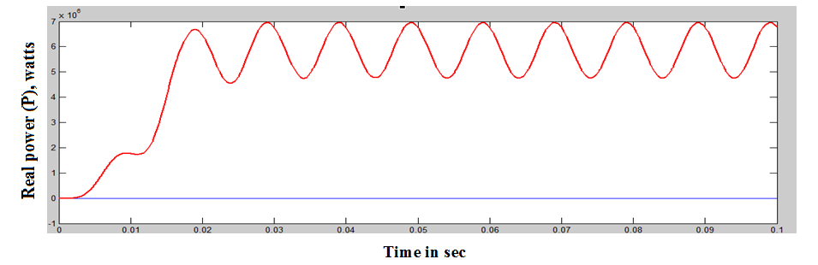

**Reactive power flow**

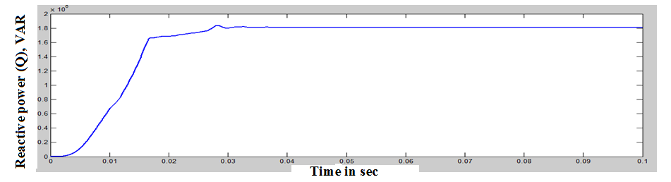

**Fig.6.6. Simulation result for STATCOM**

Real and reactive power flows obtained by varying the capacitor value till 1500μF are tabulated below

TABLE: 6.2. Variation of power flow with change in capacitance of STATCOM

|  |  |  |  |
| --- | --- | --- | --- |
| SL.NO | Capacitance  (µf) | Real power  (MW) | Reactive power  (MVAR) |
| 1 | 50 | 0.60 | 0.90 |
| 2 | 200 | 0.73 | 1.025 |
| 3 | 350 | 0.85 | 1.20 |
| 4 | 500 | 1.0 | 1.42 |
| 5 | 600 | 1.135 | 1.6 |
| 6 | 800 | 1.43 | 2.05 |
| 7 | 1000 | 1.8 | 2.5 |
| 8 | 1200 | 2.235 | 3.12 |
| 9 | 1400 | 2.6 | 3.68 |
| 10 | 1500 | 2.7 | 3.82 |

Thus we see that increase in the value of capacitance results in the improvement of both real and reactive power flows thereby compensating the system to a large extent. At capacitance value of 1500μF, compensator injects more real (2.7MW) and reactive (3.82MVAR) power to the system and receiving end voltage obtained is 4.5 kV. At this point STATCOM will inject more reactive power than SVC.

**6.4 Thyristor controlled series capacitor compensated system (TCSC)**

The above model shows a Thyristor Controlled Series Capacitor connected to the system. In TCSC simulation model, inductor is fixed at 100mH and results are obtained for different capacitor values. Results obtained after simulation is shown below



**Fig.6.7.MATLAB/SIMULINK Model of TCSC**

**Real power flow**

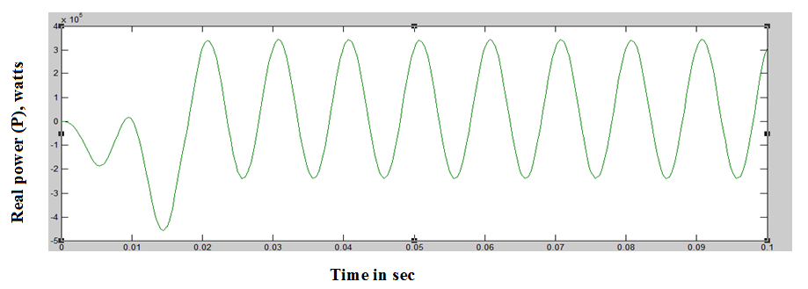

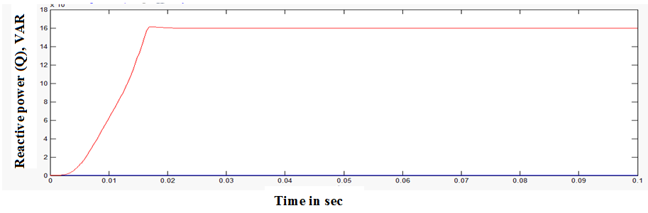 **Reactive power flow**

**Fig.6.8.Simulation result for TCSC**

Above graphs are plotted when model is simulated with capacitor value 350μF.The plots show the improvement in the load voltage (V1), load current (I1), real power (P) and reactive power (Q) with the incorporation of TCSC in the system. Results obtained for different capacitor values of the controller are tabulated below

TABLE: 6.3.Variation of power flow with change in capacitance of TCSC

|  |  |  |  |
| --- | --- | --- | --- |
| SL.NO | Capacitance  (µf) | Real power  (MW) | Reactive power  (MVAR) |
| 1 | 50 | 0.57 | 0.805 |
| 2 | 200 | 0.66 | 0.93 |
| 3 | 350 | 0.772 | 1.085 |
| 4 | 500 | 0.91 | 1.28 |
| 5 | 600 | 1.02 | 1.43 |
| 6 | 800 | 1.27 | 1.80 |
| 7 | 1000 | 1.65 | 2.30 |
| 8 | 1200 | 2.03 | 2.85 |
| 9 | 1400 | 2.52 | 3.5 |
| 10 | 1500 | 2.66 | 3.7 |

From the above table we can see that increasing the value of capacitance results in continuous compensation of real and reactive power without deterioration. Receiving end voltage improves from 2 kV to 3.8 kV Voltage profile improves up to a certain point depending on capacitance value.

**6.5 Static synchronous series compensated system (SSSC)**



**Fig.6.9.MATLAB/SIMULINK Model of SSSC**

The above configuration shows the compensated model for Static Synchronous Series Compensator (SSSC) connected to the system. Real and reactive powers are obtained by varying the value of capacitance connected in series with the line. Plots for power and voltage profiles are shown below

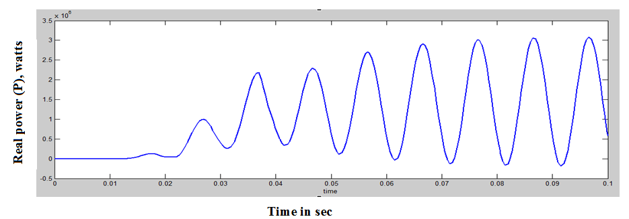

Real power flow

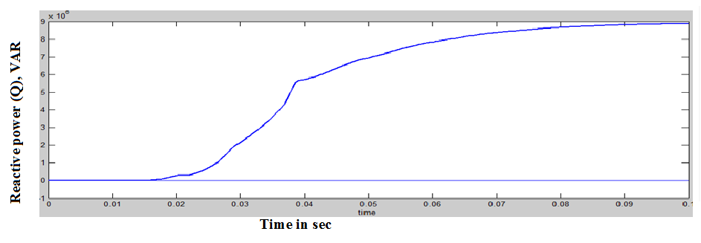

Reactive power flow

**Fig.6.10 Simulation result for SSSC**

Plots for a particular value of capacitance (350μF) are shown above. Real and reactive power variation with change in capacitance values are tabulated below

TABLE: 6.4.Variation of power flow with change in capacitance of SSSC

|  |  |  |  |
| --- | --- | --- | --- |
| SL.NO | Capacitance  (µf) | Real power  (MW) | Reactive power  (MVAR) |
| 1 | 50 | 0.025 | 0.036 |
| 2 | 200 | 0.985 | 1.38 |
| 3 | 350 | 2.08 | 2.93 |
| 4 | 500 | 1.65 | 2.34 |
| 5 | 600 | 1.40 | 2.00 |
| 6 | 800 | 1.13 | 1.60 |
| 7 | 1000 | 1.00 | 1.4 |
| 8 | 1200 | 0.9 | 1.28 |
| 9 | 1400 | 0.85 | 1.12 |
| 10 | 1500 | 0.83 | 1.18 |

From the above table we can see real and reactive power increases with the introduction of capacitance. But, it is also noted that compensation occurs up to a capacitor value of 350μF only if the capacitance is increased beyond this point, then real and reactive power both deteriorates. So, better compensation is obtained at a capacitor value of 350μF for this system.

**6.6 Unified Power Flow Controller Compensated system (UPFC) **

**Fig.6.11.MATLAB/SIMULINK Model of UPFC**

The above circuit shows the basic model of UPFC (unified power flow controller) connected to the system. Graphs obtained after simulation are shown below

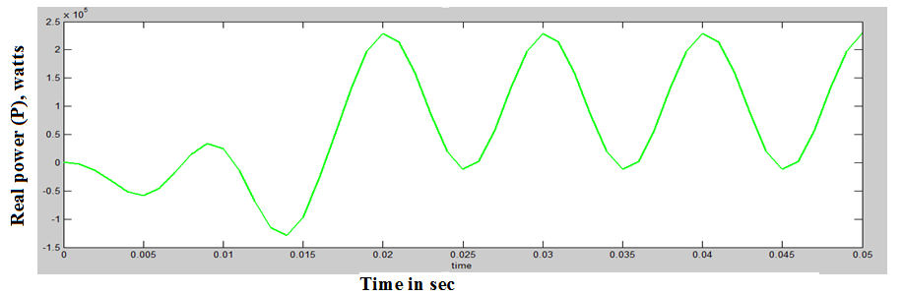

**Real power flow**

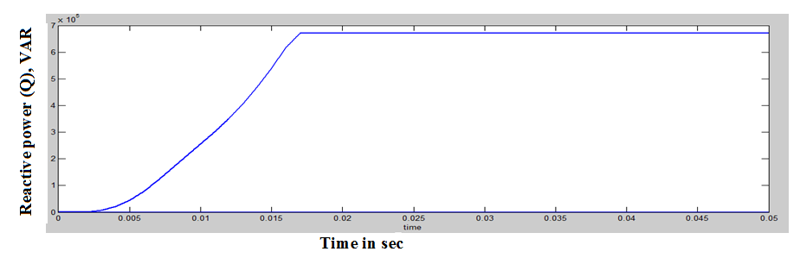

**Reactive power flow**

**Fig.6.12.Simulation result for UPFC**

The above graphs show real, reactive and receiving end voltage improvement using compensation. Graphs obtained for a particular value of capacitor rating (350uF) are shown above. Power flows obtained with change in capacitance are tabulated below

TABLE: 6.5.Variation of power flow with change in capacitance of UPFC

|  |  |  |  |
| --- | --- | --- | --- |
| SL.NO | Capacitance  (µf) | Real power  (MW) | Reactive power  (MVAR) |
| 1 | 50 | 0.0254 | 0.036 |
| 2 | 200 | 0.975 | 1.38 |
| 3 | 350 | 2.08 | 2.95 |
| 4 | 500 | 1.64 | 2.33 |
| 5 | 600 | 1.4 | 1.98 |
| 6 | 800 | 1.13 | 1.60 |
| 7 | 1000 | 1.0 | 1.40 |
| 8 | 1200 | 0.91 | 1.285 |
| 9 | 1400 | 0.85 | 1.20 |
| 10 | 1500 | 0.83 | 1.17 |

From the above table, it is seen that both power flows is improved up to a certain limit of capacitance (350μF). In this point injection of real and reactive power to the system is maximum. Beyond this, if we increase the value of capacitance then power profile is deteriorates. So, we can conclude that desirable performance is obtained at capacitor rating 350μF for UPFC compensated system.

**6.7. Comparison of power flow between above FACTS Devices**

TABLE.6.6Comparison of power flow between above FACTS Devices

|  |  |  |  |  |
| --- | --- | --- | --- | --- |
| Facts  Device | Capacitance  (350µF) | | Capacitance  (1500µF) | |
| Real power  (MW) | Reactive power  (MVAR) | Real power  (MW) | Reactive power  (MVAR) |
| FC-TCR | 0.86 | 1.21 | 2.70 | 3.80 |
| STATCOM | 0.85 | 1.20 | 2.70 | 3.82 |
| TCSC | 0.772 | 1.085 | 2.66 | 3.70 |
| SSSC | 2.08 | 2.93 | 0.83 | 1.18 |
| UPFC | 2.08 | 2.95 | 0.83 | 1.17 |

From the above table, it is seen that reactive power improvement will vary with change in capacitance in all the five cases. At a capacitor value of 350μF UPFC is seen to give best performance and at capacitor value 1500μF, STATCOM gives better performance.

**7. RESULT AND DISCUSSION**

**7.1. FC-TCR type SVC compensation**

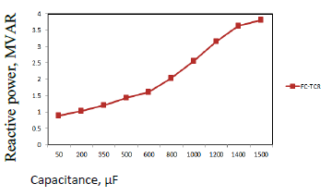

**Fig.7.1.Variation of power flow with change in capacitance (50-1500μF) of FC-TCR**

The above graph shows the variation of reactive power profile with change in capacitance for an FC-TCR type SVC connected to the system. Reactive power flows improves proportionally with increase in capacitance value. In this case, optimum performance is obtained for capacitor value of 1500μF.

**7.2. STATCOM Compensation**

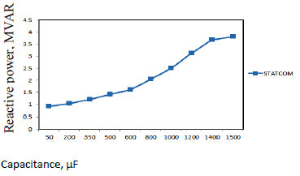

**Fig.7.2. Variation of power flow with change in capacitance (50-1500μF) of STATCOM**

Above graph shows the variation of reactive power for different capacitor values for a STATCOM connected to the system increasing the value of capacitance result in continuous compensation of reactive power.

**7.3. TCSC Compensation**

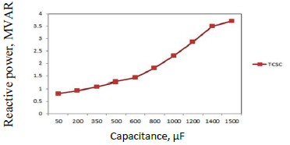

**Fig.7.3. Variation of power flow with change in capacitance (50-1500μF) of TCSC**

Above graph shows compensation of the system for varying capacitor values when a TCSC is connected to it. We can see that increase in the value of capacitance results in improvement of reactive power. In this case, a capacitor value of 1500μF gives best performance.

**7.4. SSSC Compensation**

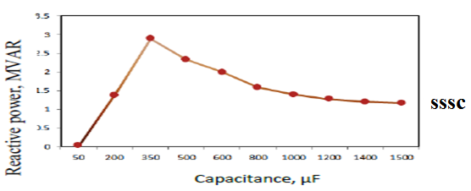

**Fig.7.4. Variation of power flow with change in capacitance (50-1500μF) of SSSC**

The above graph shows reactive power improvement after compensating the system using SSSC. It is seen that reactive power improves only up to a certain value of capacitance (350μF) beyond which it deteriorates.

**7.5. UPFC Compensation**

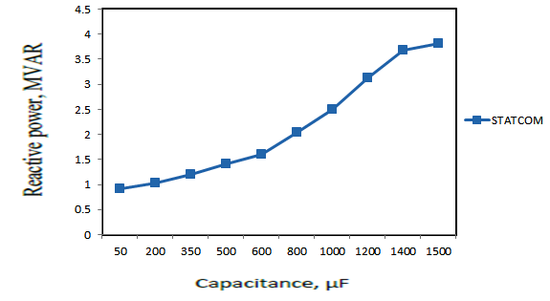

**Fig.7.5. Variation of power flow with change in capacitance (50-1500μF) of UPFC**

From the above graph it is clear that reactive power flow is improved impressively up to a capacitor rating of 350μF beyond which it deteriorates.

**7.6.** **Comparison of power flow between above FACTS devices** 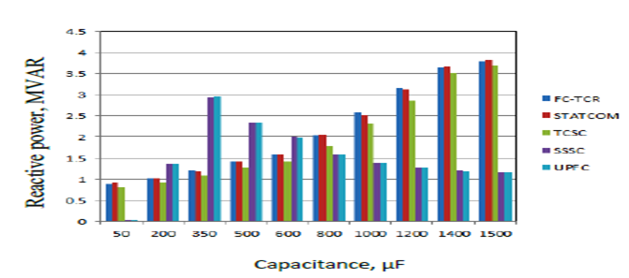

**Fig.7.6. Comparison of power flow between above FACTS devices**

Variation of power flow between above FACTS devices with change in capacitance (50-1500μF) The above graph shows the behavior of all the FACTS devices for different capacitor values. From this graph, it is observed that, of all FACTS devices, UPFC gives best performance for a capacitor value of 350μF after which its performance deteriorates. Again we see, that the performance of STATCOM continues to improve with increasing capacitance. But, increasing the capacitor rating means increasing the overall cost of the equipment. So, after comparing the performances of all the five FACTS devices, it can be concluded that desirable performance is obtained with the addition of UPFC to the system for a capacitor value of around 350 μF, all other parameters remaining unchanged.



**REFERENCES**

[1] George J. Wakileh, Power system harmonics, fundamentals, analysis and filter design, New York, Springer-Verlog Berlin Heidelberg, 2001, pp 81-103.

[2] IEEE recommended practices & requirements for harmonic control in electrical power systems, IEEE 519 standard, 1993.

[3] Arindam Ghosh and Gerard Ledwich, Power quality enhancement using custom power devices, London, Kluwer Academic Publishers, 2002, pp 55-111.

[4] B. Singh, K. A. Haddad and Ambrish Chandra, "A review of active filters for power quality improvement", IEEE trans. Industrial Electronics, Vol. 46, No.5, Oct.99.

[5] A.Elnady and Magdy M.A.Salama,"Unified approach for mitigating voltage sag and voltage flicker using the DSTATCOM", IEEE trans. Power Delivery, Vol.20, No.2, April 2005.

[6] D. Thukaram., A. Lomi and S Chirarttananon, "Minimization of harmonics under three phase unbalanced operation of static VAR compensators", Proceedings of the 12th International Conference on Power Quality, Chicago, U.S.A., 1999.

[7] Athula Rajapakse, Anawat Puangpairoj, Surapong Chirarattananon, and D.Thukaram, "Harmonic Minimizing Neural Network SVC Controller for Compensating Unbalanced Fluctuating Loads", 10th International Conference on Harmonics & quality of power 2002, vol.2, pp 403-408, Oct. 2002,..

[8] Gaber El-Saady, "Adaptive Static VAR controller for simultaneous elimination of voltage flickers and phase current imbalances due to arc furnaces loads", Electric Power Systems Research, vol.58, ppl33-140, 2001